📝 NOTES APPLICATION

📌 ABSTRACT
The Notes Application is a console-based application developed using the C programming language. The main purpose of this project is to help users create, store, manage, and retrieve notes efficiently using file handling techniques.
This application provides features such as adding notes, viewing all notes, editing existing notes, deleting notes, and searching notes by title. All notes are stored in a file, ensuring data persistence even after the program is closed. The project uses core C concepts like structures, functions, file operations, loops, and conditional statements, making it suitable for a college-level academic project.

💻 SOURCE CODE (C LANGUAGE)
#include <stdio.h>
#include <stdlib.h>

/* Function declarations */
void createNote();
void viewNote();
void deleteNote();

int main() {
int choice;

do {
printf("\n===== NOTES APPLICATION =====\n");
printf("1. Create Note\n");
printf("2. View Note\n");
printf("3. Delete Note\n");
printf("4. Exit\n");
printf("Enter your choice: ");
scanf("%d", &choice);
getchar(); // clear newline left by scanf

switch (choice) {
case 1:
createNote();
break;
case 2:
viewNote();
break;
case 3:
deleteNote();
break;
case 4:
printf("Exiting program... Thank you!\n");
break;
default:
printf("Invalid choice! Try again.\n");
}
} while (choice != 4);

return 0;
}

/* Function to create a note */
void createNote() {
FILE *fp;
char filename[50];
int ch;

printf("Enter note name (with .txt): ");
scanf("%s", filename);
getchar(); // clear buffer

fp = fopen(filename, "w");
if (fp == NULL) {
printf("Error creating file!\n");
return;
}

printf("Enter note content (Press # to save):\n");

while ((ch = getchar()) != '#') {
fputc(ch, fp);
}

fclose(fp);
printf("Note saved successfully.\n");
}

/* Function to view a note */
void viewNote() {
FILE *fp;
char filename[50];
int ch;

printf("Enter note name to view: ");
scanf("%s", filename);
getchar(); // clear buffer

fp = fopen(filename, "r");
if (fp == NULL) {
printf("Note not found!\n");
return;
}

printf("\n--- Note Content ---\n");
while ((ch = fgetc(fp)) != EOF) {
putchar(ch);
}
printf("\n--------------------\n");

fclose(fp);
}

/* Function to delete a note */
void deleteNote() {
char filename[50];

printf("Enter note name to delete: ");
scanf("%s", filename);
getchar(); // clear buffer

if (remove(filename) == 0) {
printf("Note deleted successfully.\n");
} else {
printf("Error deleting note.\n");
}
}

🧪 RESULT
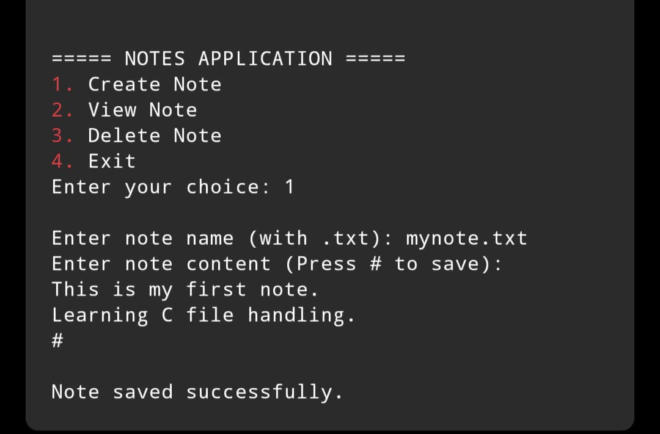

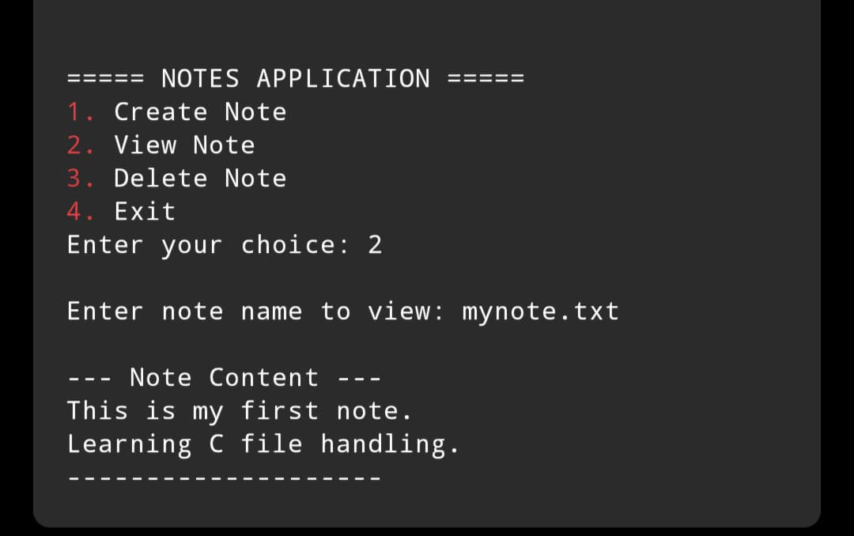

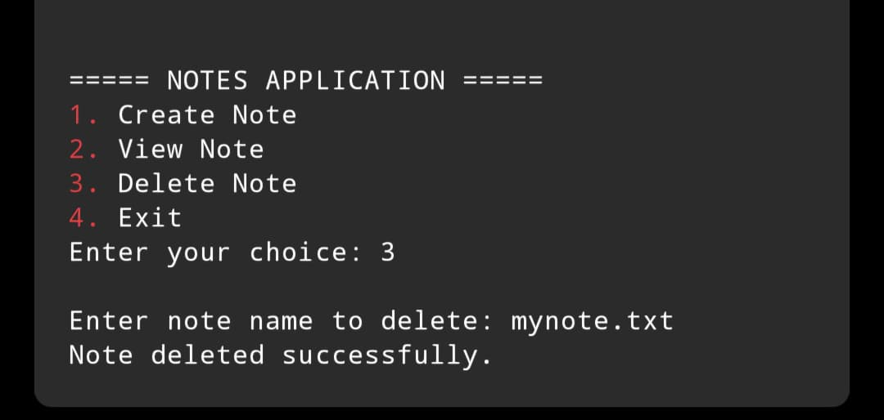

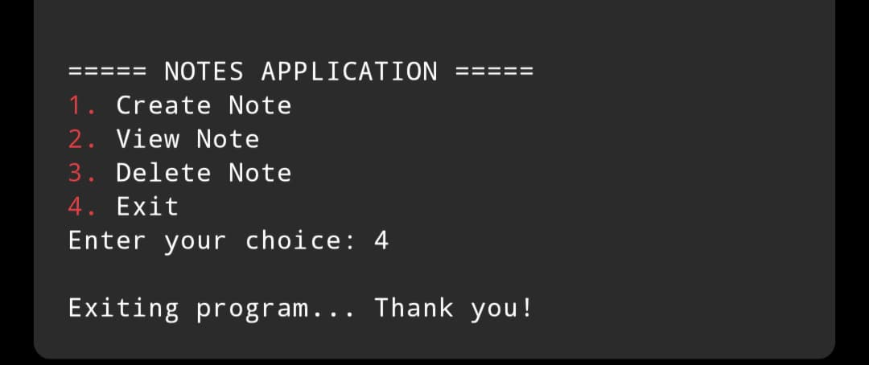

✅ CONCLUSION
The Notes Application developed using C language fulfills its objective of managing notes efficiently through a simple menu-driven interface.
The project demonstrates effective use of structures, file handling, and modular programming concepts.
This application is ideal for a college-level project and can be enhanced further by addingfeatures such as password protection, date and time for notes, or a graphical user interface.

